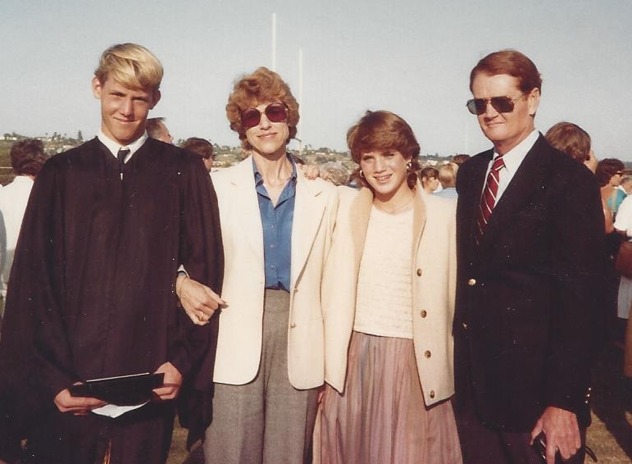

Brian, Mary Jo, Elaine, Jack Moore - June 1984

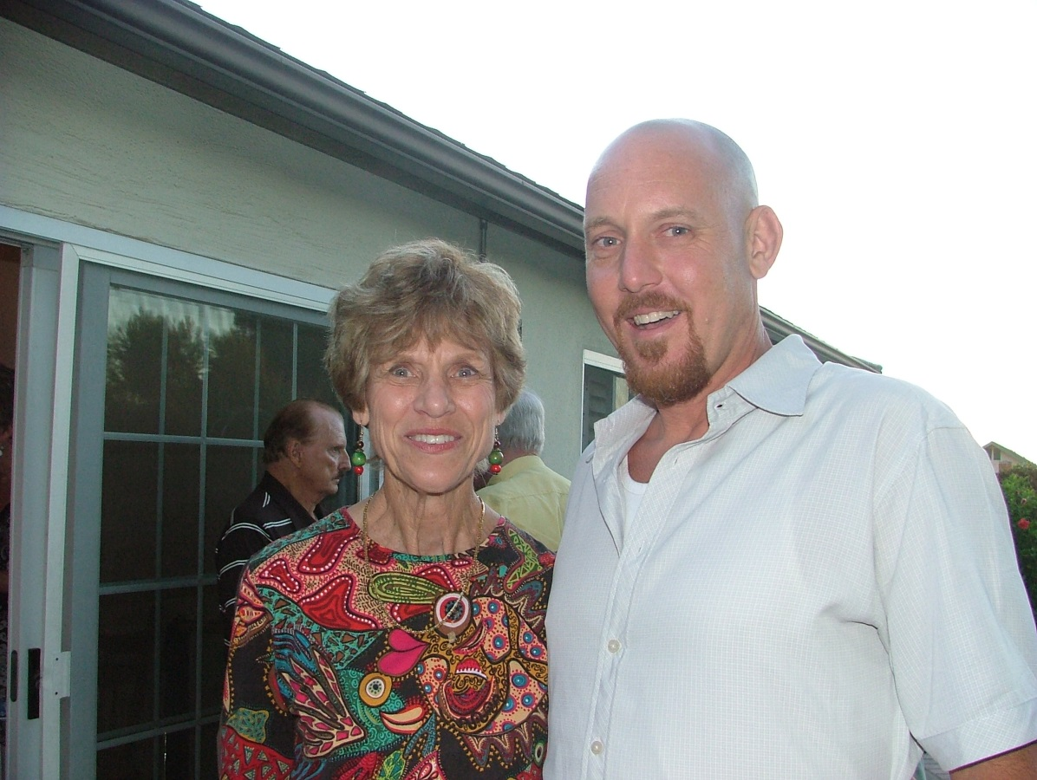

Mary Jo Wolfe Moore McCall and son, Brian Moore – 2007